SANSKAAR PATNI
180905134 CSE C-23
CN Lab 3

5.1)
1.
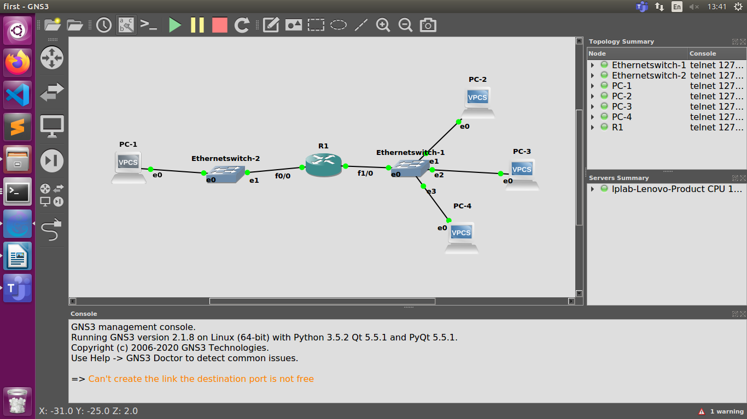
2.PC s configured and added R1 default gateway
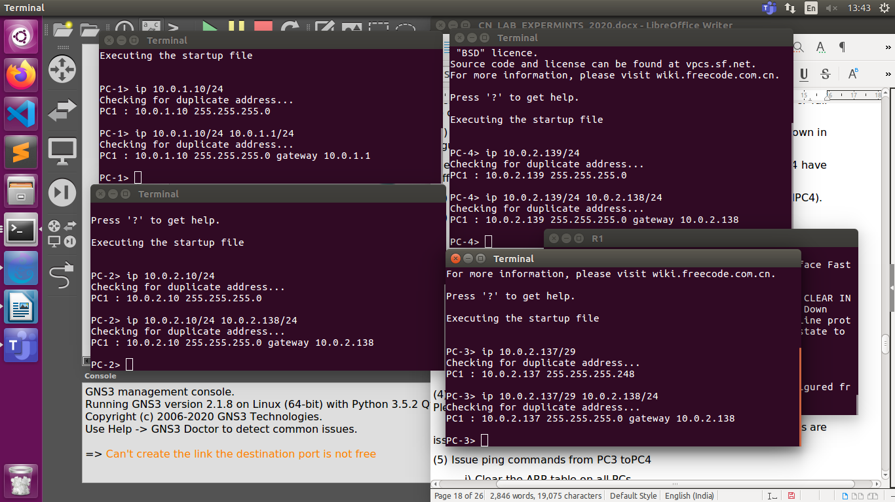
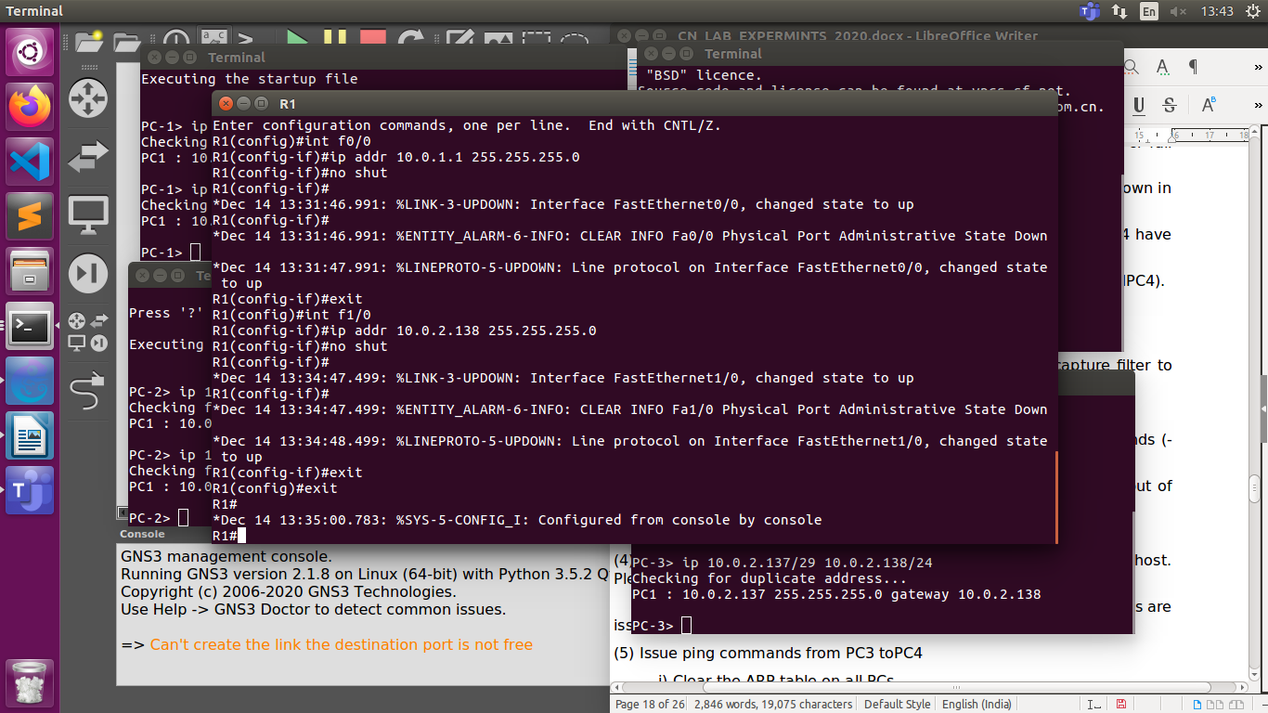
3. Ping commands from PC1 to PC3 ATLEAST TWICE

ping 10.0.2.137/29
10.0.2.137 icmp_seq=1 timeout
84 bytes from 10.0.2.137 icmp_seq=2 ttl=63 time=20.276 ms
84 bytes from 10.0.2.137 icmp_seq=3 ttl=63 time=14.806 ms
84 bytes from 10.0.2.137 icmp_seq=4 ttl=63 time=15.614 ms
84 bytes from 10.0.2.137 icmp_seq=5 ttl=63 time=15.607 ms

ping 10.0.2.137/29
10.0.2.137 icmp_seq=1 timeout
10.0.2.137 icmp_seq=2 timeout
84 bytes from 10.0.2.137 icmp_seq=3 ttl=63 time=13.280 ms
84 bytes from 10.0.2.137 icmp_seq=4 ttl=63 time=15.493 ms
84 bytes from 10.0.2.137 icmp_seq=5 ttl=63 time=15.422 ms

SHOWING ARP TABLE PC1
show arp
ca:01:0c:f8:00:00 10.0.1.1 expires in 91 seconds
SHOWING ARP TABLE PC3
show arp

ca:01:0c:f8:00:1c 10.0.2.138 expires in 105 seconds

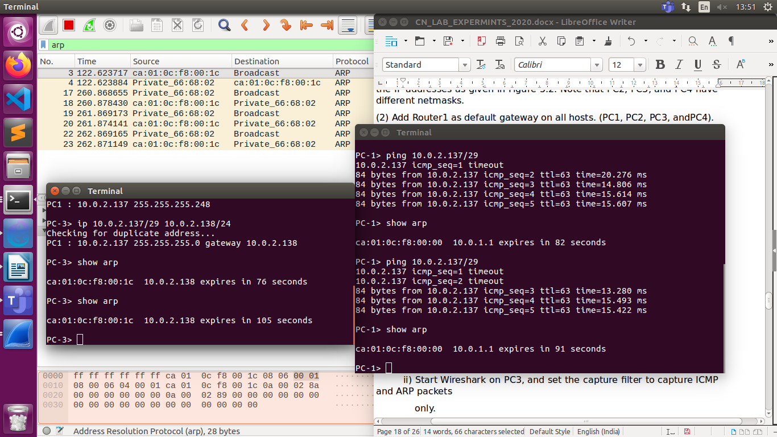
WIRESHARK OF PC1 AND PC3
PC1 Link
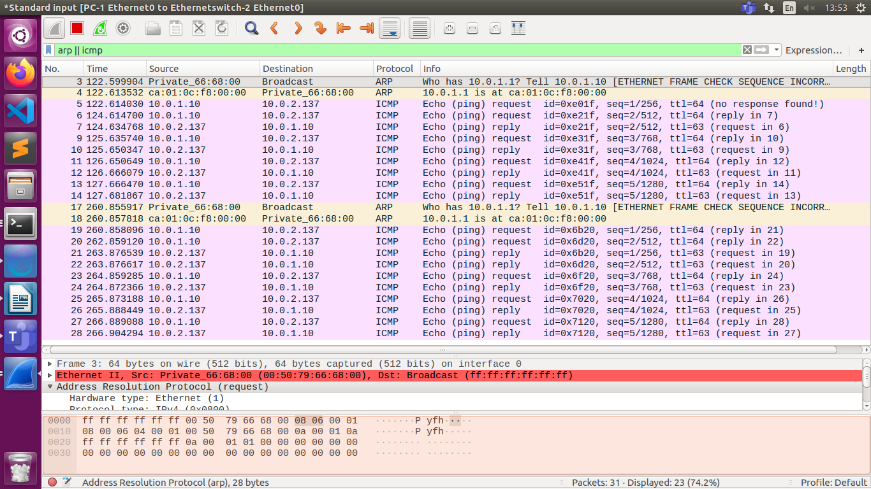
PC3 link
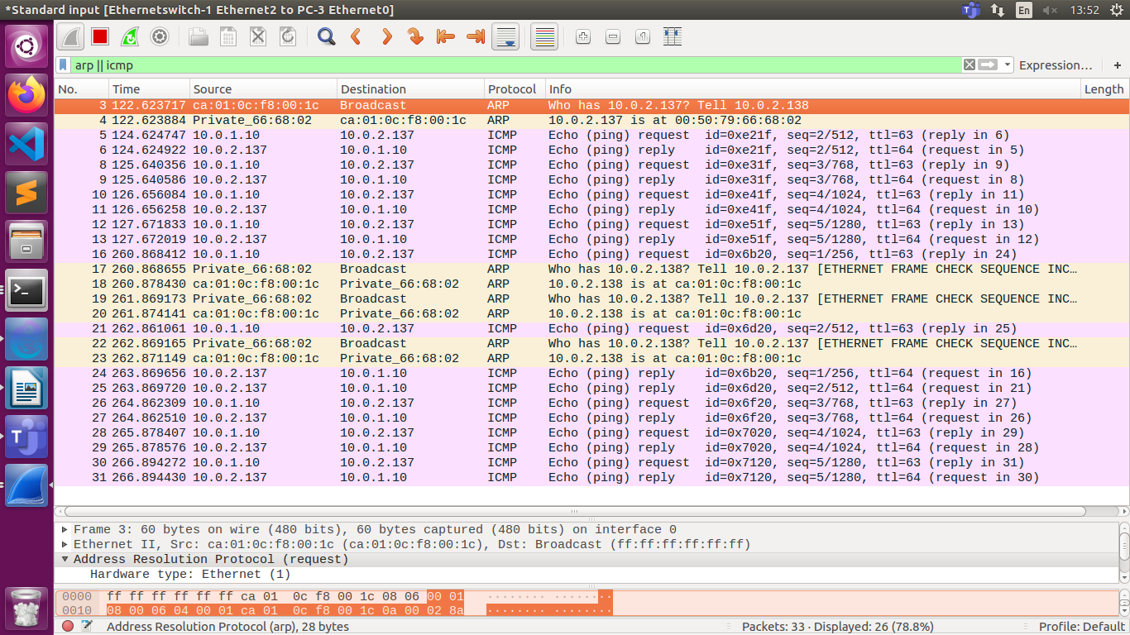
4.Router Cache
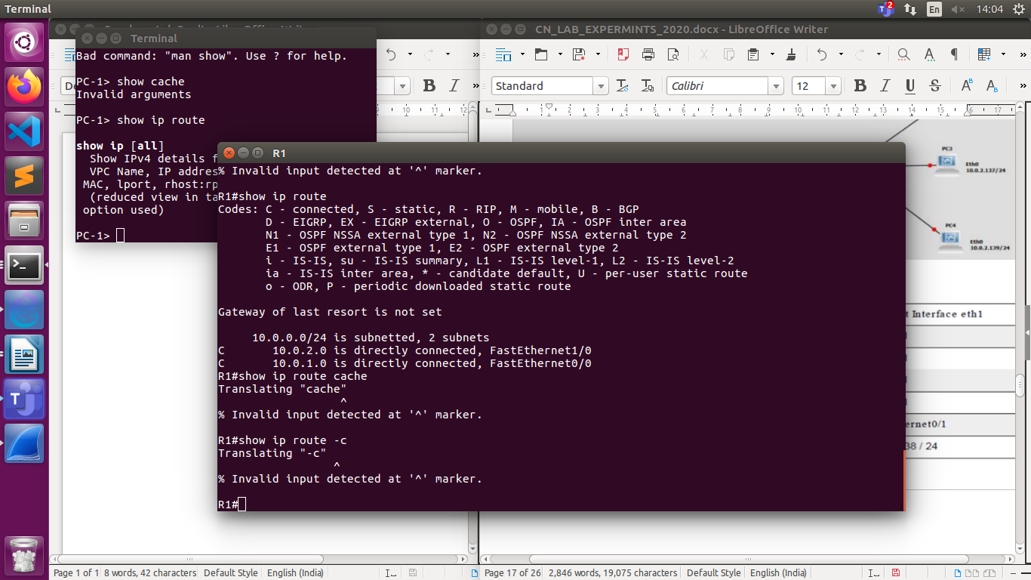

5. ping from pc3 to pc4

ping 10.0.2.139/24
84 bytes from 10.0.2.139 icmp_seq=1 ttl=64 time=0.334 ms
84 bytes from 10.0.2.139 icmp_seq=2 ttl=64 time=0.330 ms
84 bytes from 10.0.2.139 icmp_seq=3 ttl=64 time=0.379 ms
84 bytes from 10.0.2.139 icmp_seq=4 ttl=64 time=0.357 ms
84 bytes from 10.0.2.139 icmp_seq=5 ttl=64 time=0.349 ms

PC-3> show arp
00:50:79:66:68:03 10.0.2.139 expires in 67 seconds
PC-4> show arp

00:50:79:66:68:02 10.0.2.137 expires in 31 seconds

Wireshark when we ping pc3 to pc4
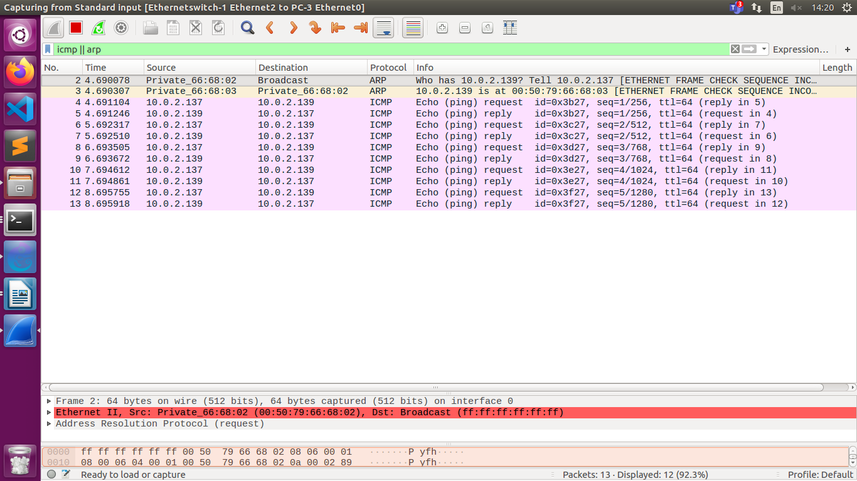
Ping PC3 to PC2

ping 10.0.2.10/24 -c3
84 bytes from 10.0.2.10 icmp_seq=1 ttl=64 time=0.307 ms
84 bytes from 10.0.2.10 icmp_seq=2 ttl=64 time=0.339 ms
84 bytes from 10.0.2.10 icmp_seq=3 ttl=64 time=0.389 ms
84 bytes from 10.0.2.10 icmp_seq=4 ttl=64 time=0.353 ms
84 bytes from 10.0.2.10 icmp_seq=5 ttl=64 time=0.340 ms

PC-3>show arp

00:50:79:66:68:01 10.0.2.10 expires in 57 seconds
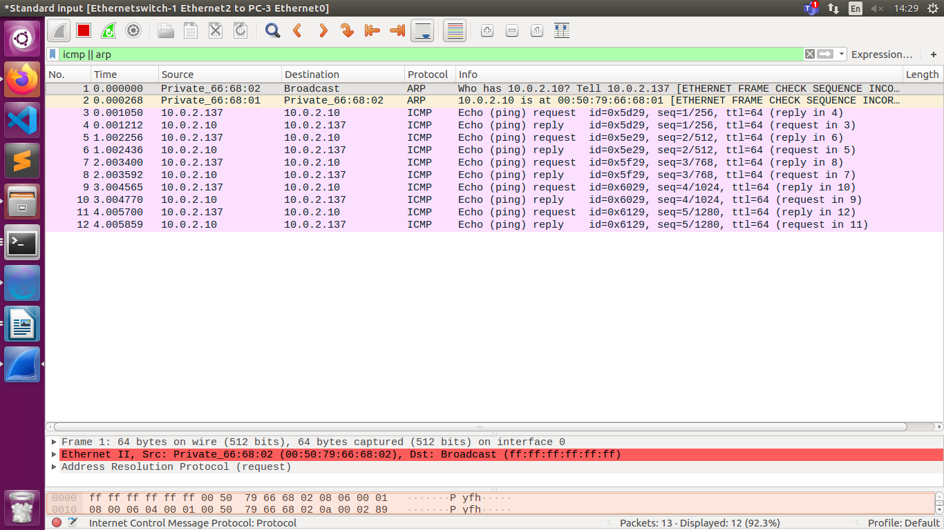

SUBNETTING
Q2
14.24.74.0/24.
a.b.c.d/x
first 24 bits are prefix
so we have 8 bits left
2^8=256 addresses possible
The first address is 14.24.74.0/24; The last address is 14.24.74.255/24.
To satisfy the third requirment ,we assign addresses to subblocks, starting with the the largest and ending with the smallest one.
PC-1) The number of addresses in the largest subblock ,which requires 120 addresses, is not power of 2, we allocate 2^7=128 addresses .The subnet mask for this subnet can be found as 32 -log2(128) =25. The first address in this block is 14.24.74.0/25(00001110.00011000.01001010.00000000) ; the last address is 14.24.74.127/25(00001110.00011000.01001010.01111111).
PC-2)The number of addresses in the second largest subblock , which requires 60 addresses , is not a power of 2 either, we allocate 64 addresses .The subnet mask for this subnet can be found as 32 - log2(64) = 26.The first address in this block is 14.24.74.128/26(00001110.00011000.01001010.10000000);The last address is 14.24.74.191/26(00001110.00011000.01001010.10111111)
PC-3) The number of addresses in the smallest subblock ,which requires 10 addresses, is not a power of 2 either.we allocate 16 addresses.The subnet mask for this subnet can be found as 32-log2(16) = 28. The first address in this block is 14.24.74.192/28(00001110.00011000.01001010.11000000); The last address is 14.24.74.207/28(00001110.00011000.01001010.11001111)

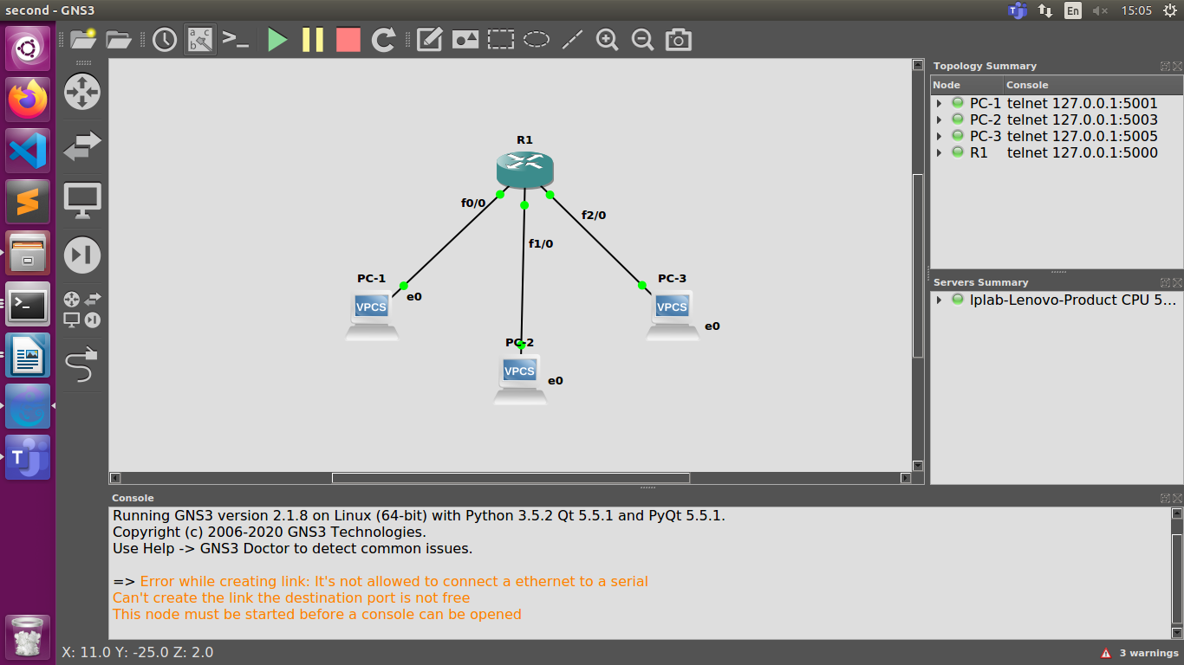

PC-1 TAKING AS THE ONE WHICH NEEDS 120 ADDRESSES
PC-1> ip 14.24.74.1/25 14.24.74.126/25

PC-2 TAKING AS THE ONE WHICH NEEDS 60 ADDRESSES
PC-2> ip 14.24.74.129/26 14.24.74.190/26

PC-3 TAKING AS THE ONE WHICH NEEDS 10 ADDRESSES
PC-3> ip 14.24.74.193/28 14.24.74.206/28

ROUTER CONFIGURATION
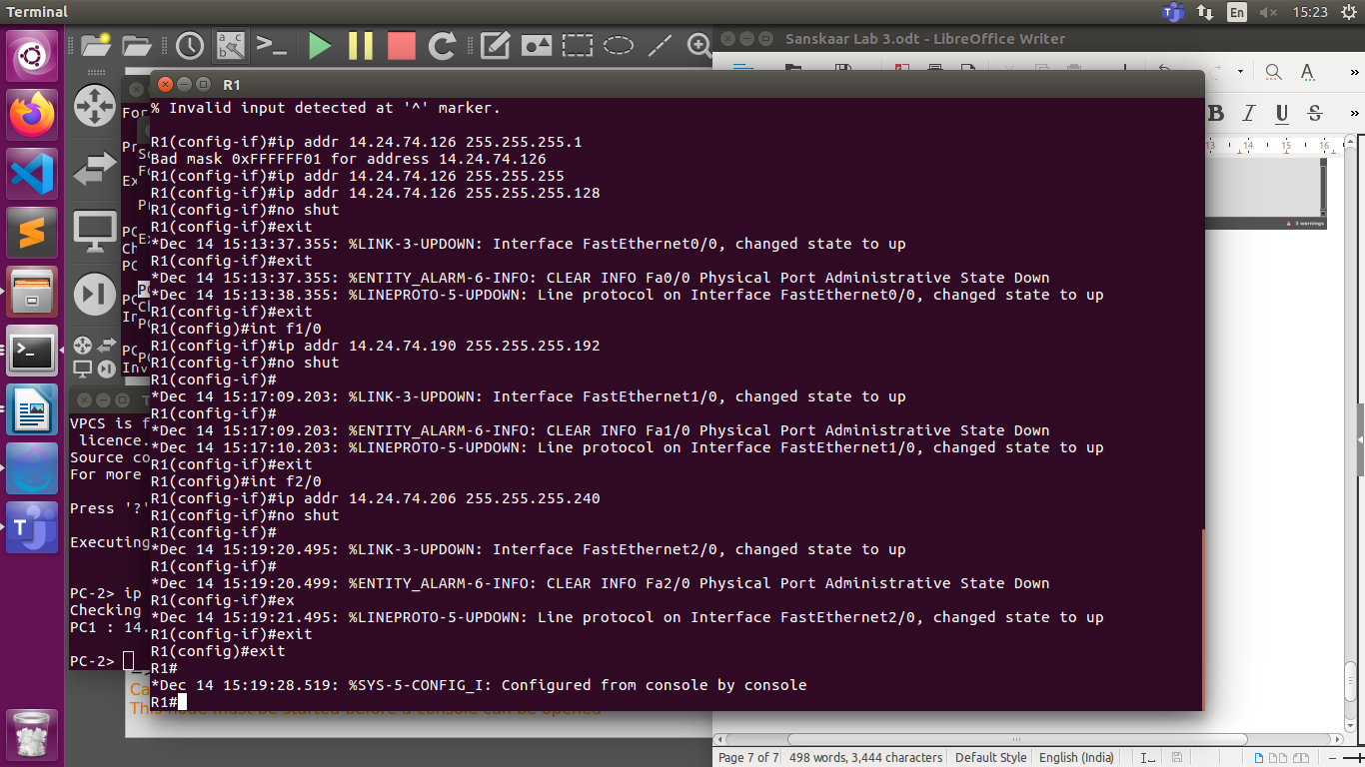
ping from pc1 to pc2
14.24.74.129 icmp_seq=1 timeout
84 bytes from 14.24.74.129 icmp_seq=2 ttl=63 time=20.208 ms
84 bytes from 14.24.74.129 icmp_seq=3 ttl=63 time=15.079 ms
84 bytes from 14.24.74.129 icmp_seq=4 ttl=63 time=15.376 ms
84 bytes from 14.24.74.129 icmp_seq=5 ttl=63 time=15.449 ms

ping from pc1 to pc3
ping 14.24.74.193/28
14.24.74.193 icmp_seq=1 timeout
84 bytes from 14.24.74.193 icmp_seq=2 ttl=63 time=18.926 ms
84 bytes from 14.24.74.193 icmp_seq=3 ttl=63 time=15.812 ms
84 bytes from 14.24.74.193 icmp_seq=4 ttl=63 time=15.863 ms
84 bytes from 14.24.74.193 icmp_seq=5 ttl=63 time=14.933 ms

ping from pc2 to pc3
ping 14.24.74.193/28
84 bytes from 14.24.74.193 icmp_seq=1 ttl=63 time=17.512 ms
84 bytes from 14.24.74.193 icmp_seq=2 ttl=63 time=15.519 ms
84 bytes from 14.24.74.193 icmp_seq=3 ttl=63 time=15.486 ms
84 bytes from 14.24.74.193 icmp_seq=4 ttl=63 time=15.288 ms
84 bytes from 14.24.74.193 icmp_seq=5 ttl=63 time=15.157 ms

ping from pc3 to pc1
ping 14.24.74.1/25
14.24.74.1 icmp_seq=1 timeout
14.24.74.1 icmp_seq=2 timeout
84 bytes from 14.24.74.1 icmp_seq=3 ttl=63 time=13.474 ms
84 bytes from 14.24.74.1 icmp_seq=4 ttl=63 time=15.166 ms
84 bytes from 14.24.74.1 icmp_seq=5 ttl=63 time=15.215 ms

Q7.1)DHCP
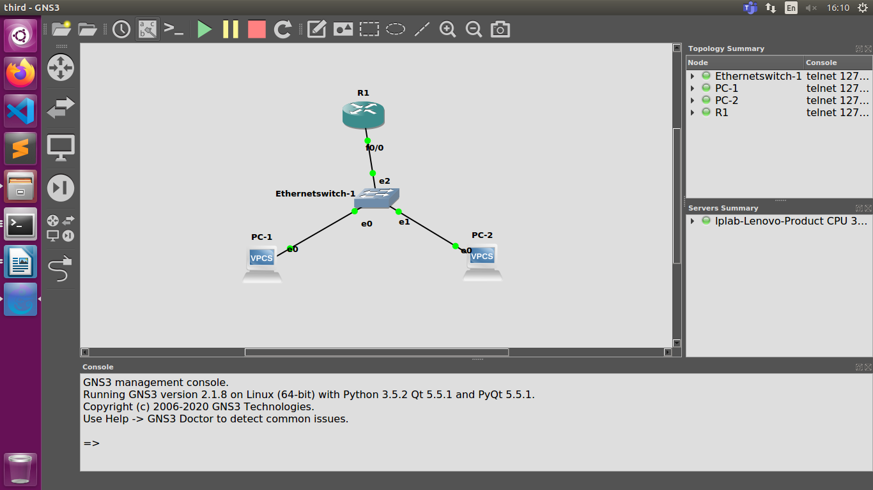

Configuring Router as DHCP Server and configuring the interface
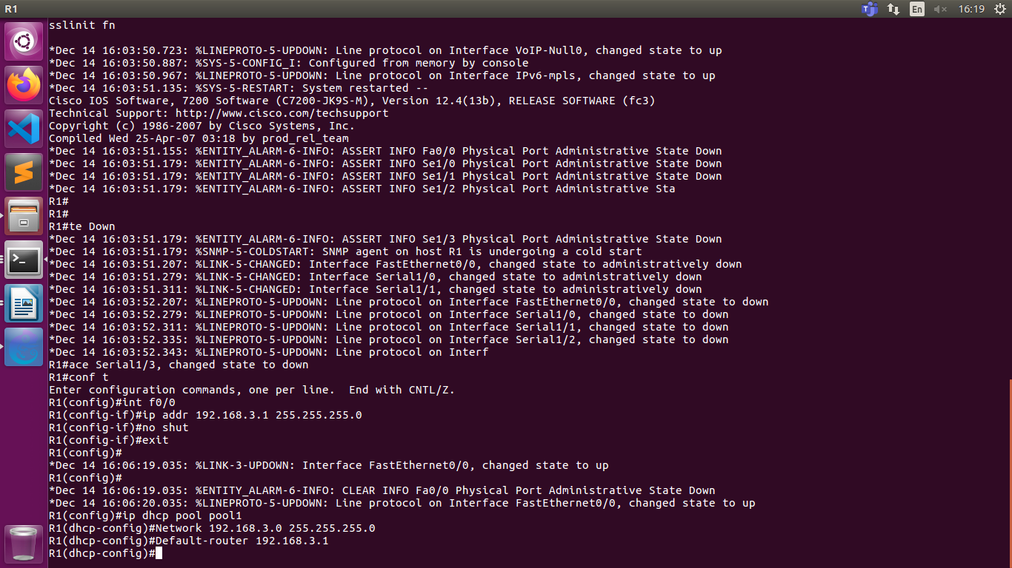
Running the command dhcp on PC1 and PC2
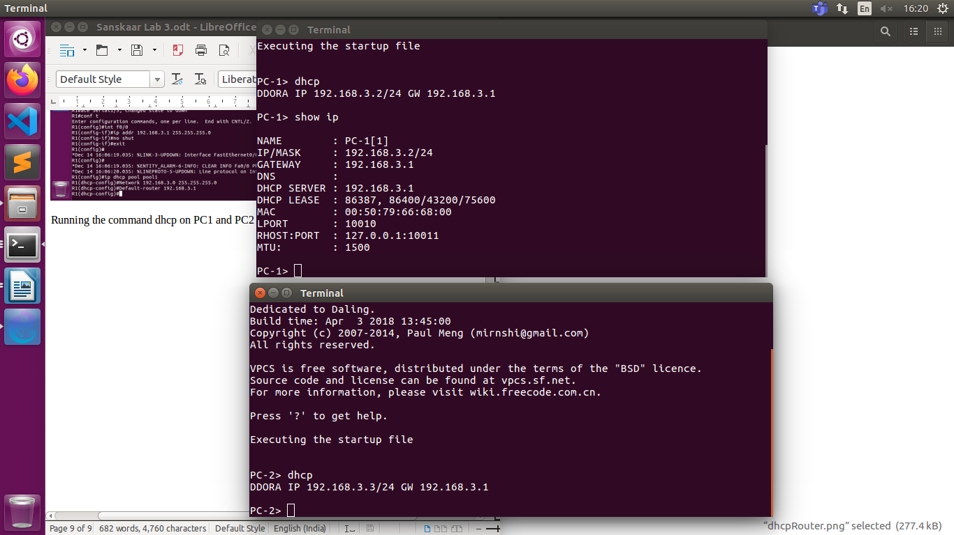
The DHCP server assigns ip to Pcs
PC-1> dhcp
DDORA IP 192.168.3.2/24 GW 192.168.3.1
PC-2> dhcp
DDORA IP 192.168.3.3/24 GW 192.168.3.1

Wireshark capture for f0/0
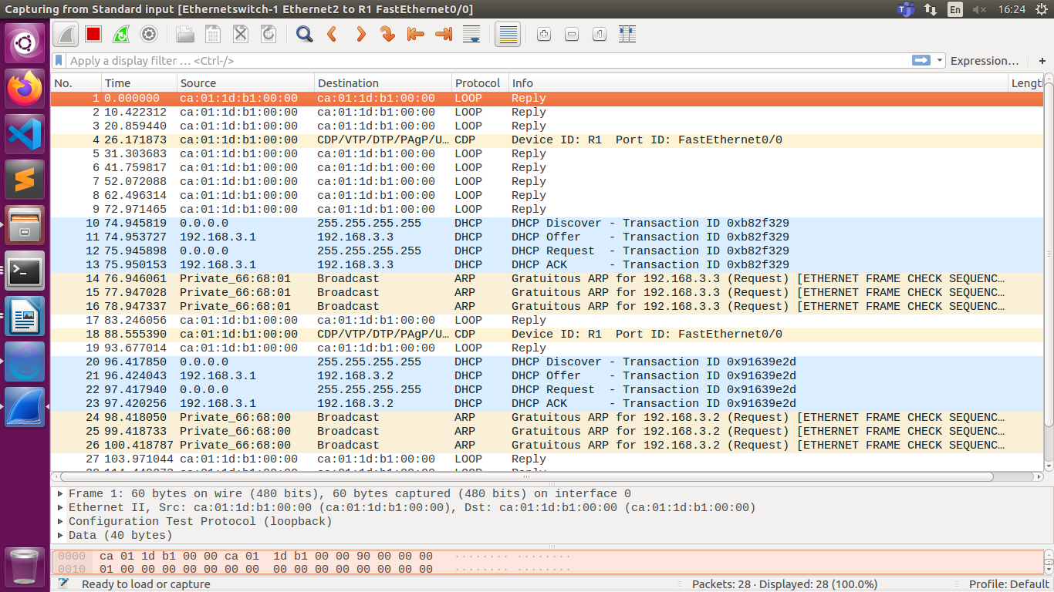
DHCP- SUBNET
Could not screen shot the router terminal picture

Configuring Router interfaces:
Same steps as Subnet qsn
Configuring Router as DHCP Server:

All Ips assigned using DHCP matched to the ones I set manually in 7.2
